Note:

Students will not get hints on how to unlock the Micro:Bit. They will have to figure it out. This document is for grading purposes. Unlock key found at bottom.

To Test Lock Code:

1. Live Demo:

Go to this link to Demo the published code: [Link](https://makecode.microbit.org/_6JHMz8ffvFuo)

1. Upload to Micro:Bit:

Upload the “code/LockCode.hex” file to a physical Micro:Bit via USB connection.

Note: Must hold GND pin to activate with finger

1. Paste into editor:

Paste the “code/LockCode” file’s text into the JavaScript side of the MicroBit editor ([Link](https://makecode.microbit.org))

Note: make sure you change the editor to JavaScript mode 

How the lock works:

1. Count before start:

Micro:Bit will count from 1 to 3 to signal start

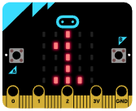 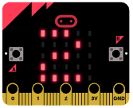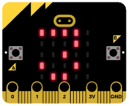

1. Code shown

Micro:Bit will flash a square between 1-7 times. This number will correspond to a binary input on the pins.

Square: 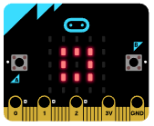

1. Timed unlock section (If guess is correct, student is given source code).

Depending on the number of squares shown, the code to unlock will map to binary on the pins

Example of 3 flashes: 1 – 0 – 0

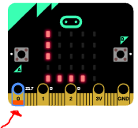

Example of 4 flashes: 1 – 0 – 1

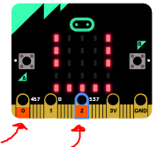

After unlocking:

Once the lock is broken, give the students the source code.

The students modify the code to their liking so they can bring home their own lock.

Mapping Key:

